FinTech Transaction and Fraud Risk Analysis
- Project Overview
- Fintech Transaction and Fraud Risk Analysis is a data analytics project that analyze financial Transaction, Understanding the customer behavior and perform fraud risk analysis.
- The Project focuses on understanding transaction patterns, transaction amount, risk levels, and fraudulent transactions.
- It also analyzes factors such as transaction category, transaction status, credit score, KYC level, bank and device type.
- The data is cleaned and analysis using Python in Google Colab and the results are visualized using Power BI.
- The main goal is to identify fraud and risk patterns and provide useful business insights for better financial risk management.

- Project Objective
- To analyze financial transaction and identify key transaction patterns and trends.
- To evaluate transaction amounts, types, categories and customer behavior.
- To identify high-risk transactions using risk-related factors.
- To analyze fraudulent transaction and identify patterns that may help in fraud detection.
- To generate actionable insights to support data-driven and improve financial risk and fraud management.
- Generate business insights and recommendations.

- Data Source
Hugging face - FinTech https://huggingface.co/datasets/hari7261/FINTECH-DETAILS-DATASET
Dataset: FinTech Transaction Dataset
Domain: Financial Transaction & Fraud Risk Analysis
Dataset Size: 5000 rows & 21 columns
Key Features: Transaction ID, Customer ID, Age, City, Country, Transaction Type, Category, Amount, Bank Name, Device Type, Transaction Status, Credit Score, KYC Level, Risk Level, Is Fraud, etc.

- Problem Statement

Financial transaction datasets contain large amounts of information, making it difficult to identify transaction patterns, high-risk activities, and fraudulent transactions manually. This project analyzes transaction and customer-related data to identify important fraud and risk patterns and provide data-driven insights for better financial risk management.

- Data Cleaning & Pre-processing

Data cleaning and preprocessing were performed using Python in Google Colab. The raw FinTech transaction dataset was examined and prepared for further analysis.

The following steps were performed:

- Loaded the raw dataset using Pandas.
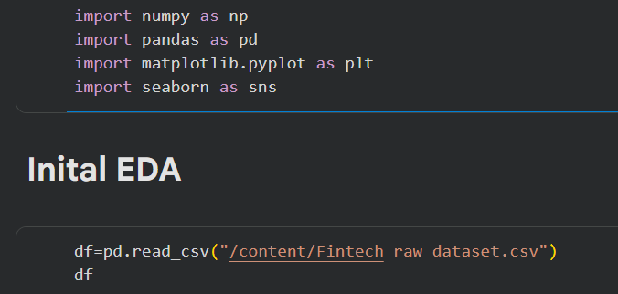

Then I performed initial EDA to understand the dataset

- Checked the first few records using head () to understand the dataset.
print(df.head()) ##To display top 5 rows

- Checked the last five records using tail () to understand the dataset

- Checked the number of rows and columns using shape.

- Examined column names and data types using info ().
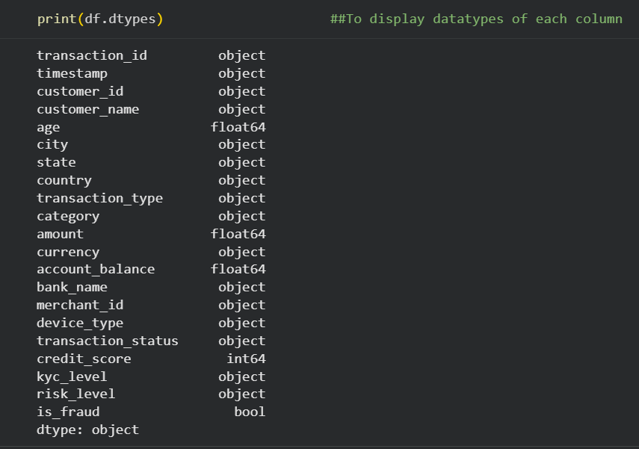

- Correct the data types
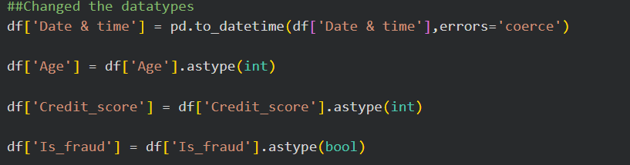

- Checked for missing/null values in the dataset.
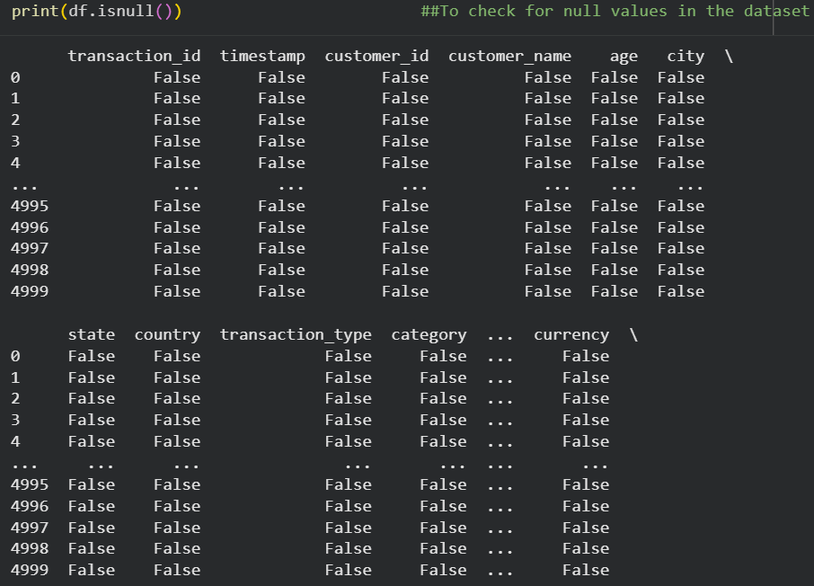

    - Calculate the number of missing/null values in the dataset
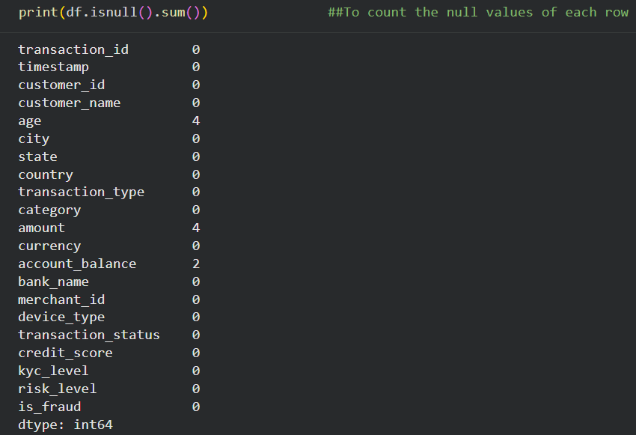

- Depending on data, I replace missing values using median
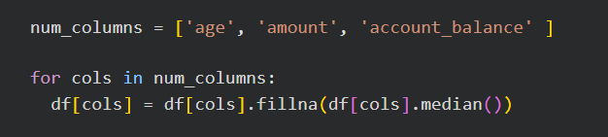

- Checked for duplicate records.
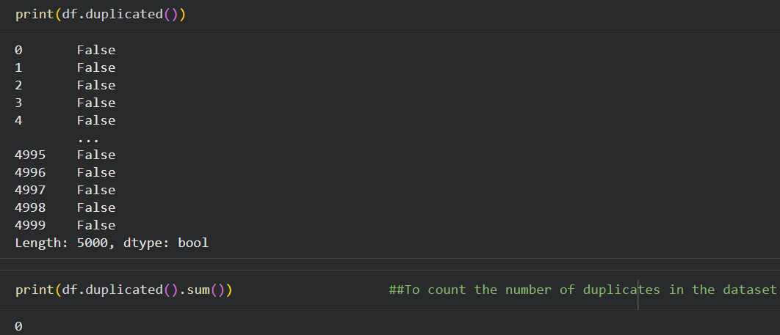
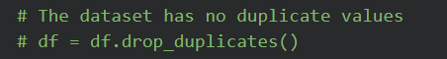
- To check & Treat the Outliers in numeric columns
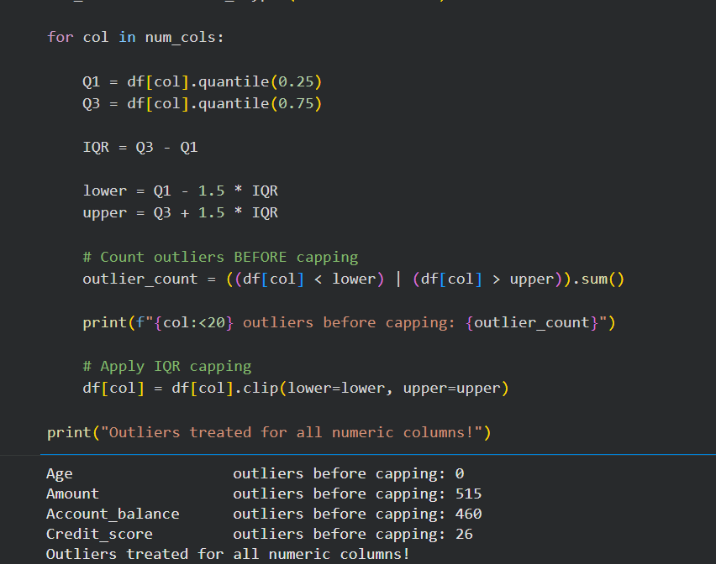
Outlier Detection and Treatment
Outliers were identified in the numerical columns using the Interquartile Range (IQR) method. The analysis identified 515 outliers in the Amount column, 460 outliers in the Account Balance column, and 26 outliers in the Credit Score column, while no outliers were detected in the Age column.
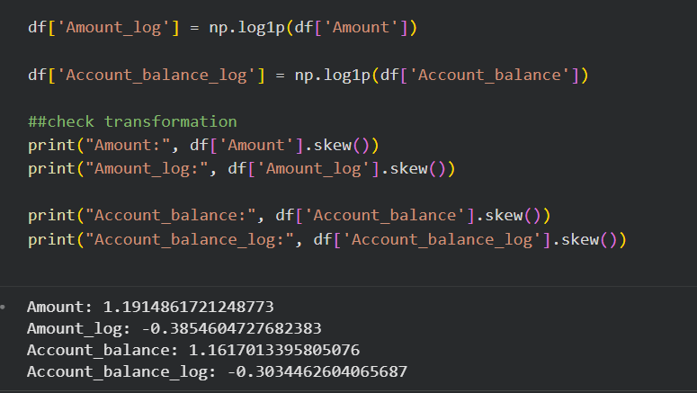
- The Amount and Account Balance variables showed high variability and skewness due to extreme values. Therefore, appropriate transformation techniques were applied to reduce skewness and minimize the influence of extreme values. After transformation, IQR-based capping was applied to control the remaining extreme observations and prepare the data for further analysis

- Prepared the dataset for further analysis and visualization.

- Tools & Technologies
- Microsoft Excel
- Power bi
- Power Query
- DAX
- Python
- NumPy
- Pandas
- Seaborn
- ChatGpt

- Performance Analysis

  - Fraud Transaction by Risk Level

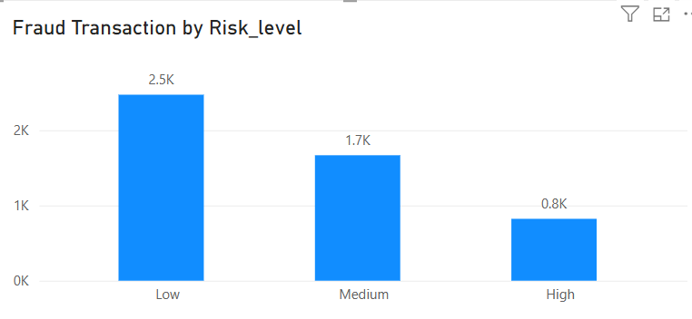

- Insight:
The chart shows that fraudulent transactions are higher in the Low and Medium risk levels, while High risk has fewer fraudulent transactions.

- Business Recommendation:
The business should improve risk classification and closely monitor Low and Medium risk transactions to identify hidden fraud.

  - Transaction Amount by Trend by Year and Month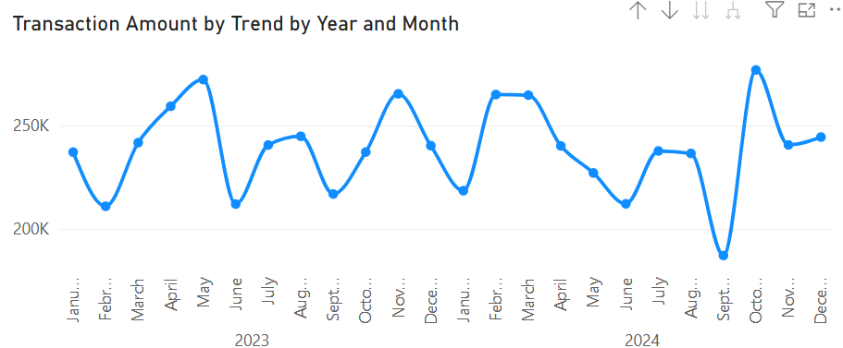
- Insight:
The transaction amount fluctuates over time, with several increases and decreases. There is no consistent upward trend.
- Business Recommendation:
The business should monitor monthly transaction patterns and investigate sudden increases or decreases to identify unusual activity.

  - Transaction Amount by Category
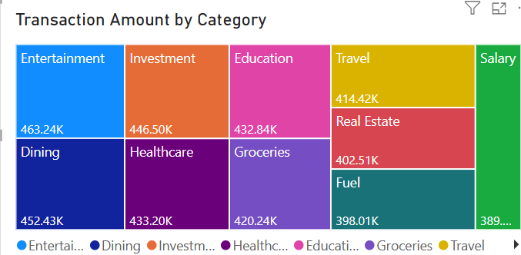
- Insight:
The transaction amount varies across different categories. Some categories contribute more transaction value than others.
- Business Recommendation:
The business should focus on high-value categories and monitor unusual transaction amounts to reduce financial risk.

  - Total Transaction by Transaction Status
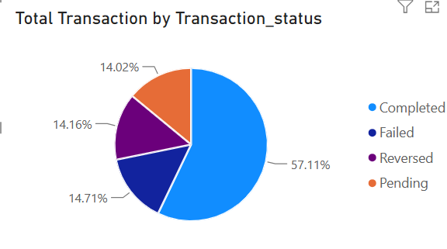
- Insight:
Most transactions are completed successfully, while failed, pending, and reversed transactions represent smaller portions.
- Business Recommendation:
The business should monitor failed and reversed transactions to identify technical issues and reduce unsuccessful transactions.
  - Average of Credit Score by KYC Level
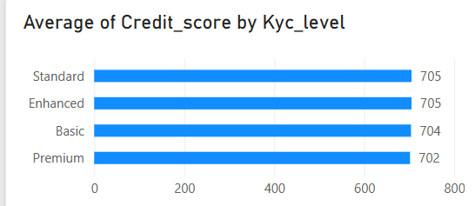
- Insight:
The average credit scores are almost similar across the different KYC levels, showing that there is no major difference in average credit score between the groups.
- Business Recommendation:
The business should not rely only on credit score. It should combine credit score with KYC level, transaction behavior, and risk level for better risk assessment.

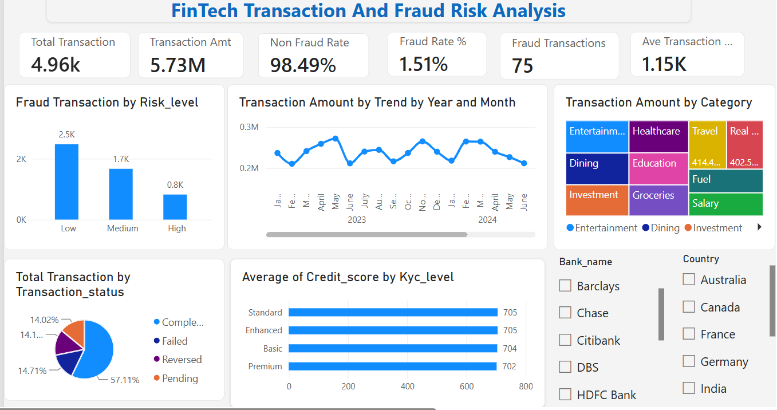

Overall Dashboard Insights
  - The dashboard shows that fraudulent transactions are present across different risk levels.
  - Transaction amounts fluctuate over time, with some periods showing higher activity.
  - Transaction values vary across different transaction categories.
  - Most transactions are successful, while a smaller number are failed, pending, or reversed.
  - Credit scores are relatively similar across different KYC levels.
Overall Business Recommendations
  - The business should continuously monitor transactions and strengthen fraud detection methods.
  - Unusual changes in transaction amounts should be investigated to identify potential risks.
  - High-value transaction categories should be monitored more closely.
  - The business should investigate failed and reversed transactions to improve transaction success.
  - Credit score should be combined with KYC, transaction behavior, and risk level for better fraud-risk assessment.

